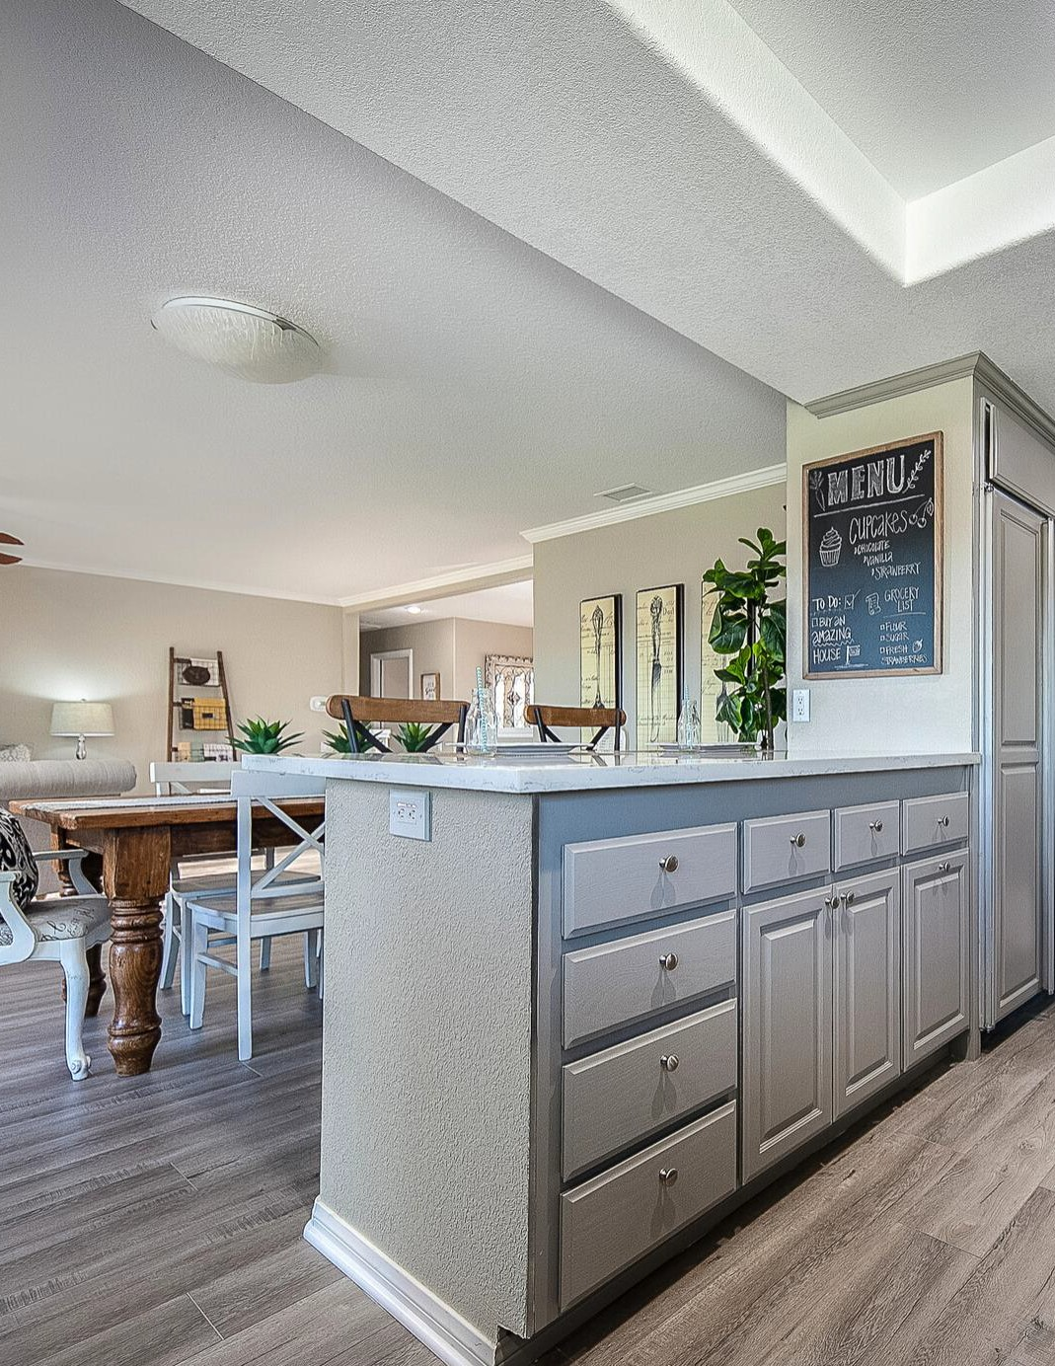







7
F A S T S A L E

S E L L Y O U R H O M E I N L E S S T I M E A N D F O R M O R E M O N E Y

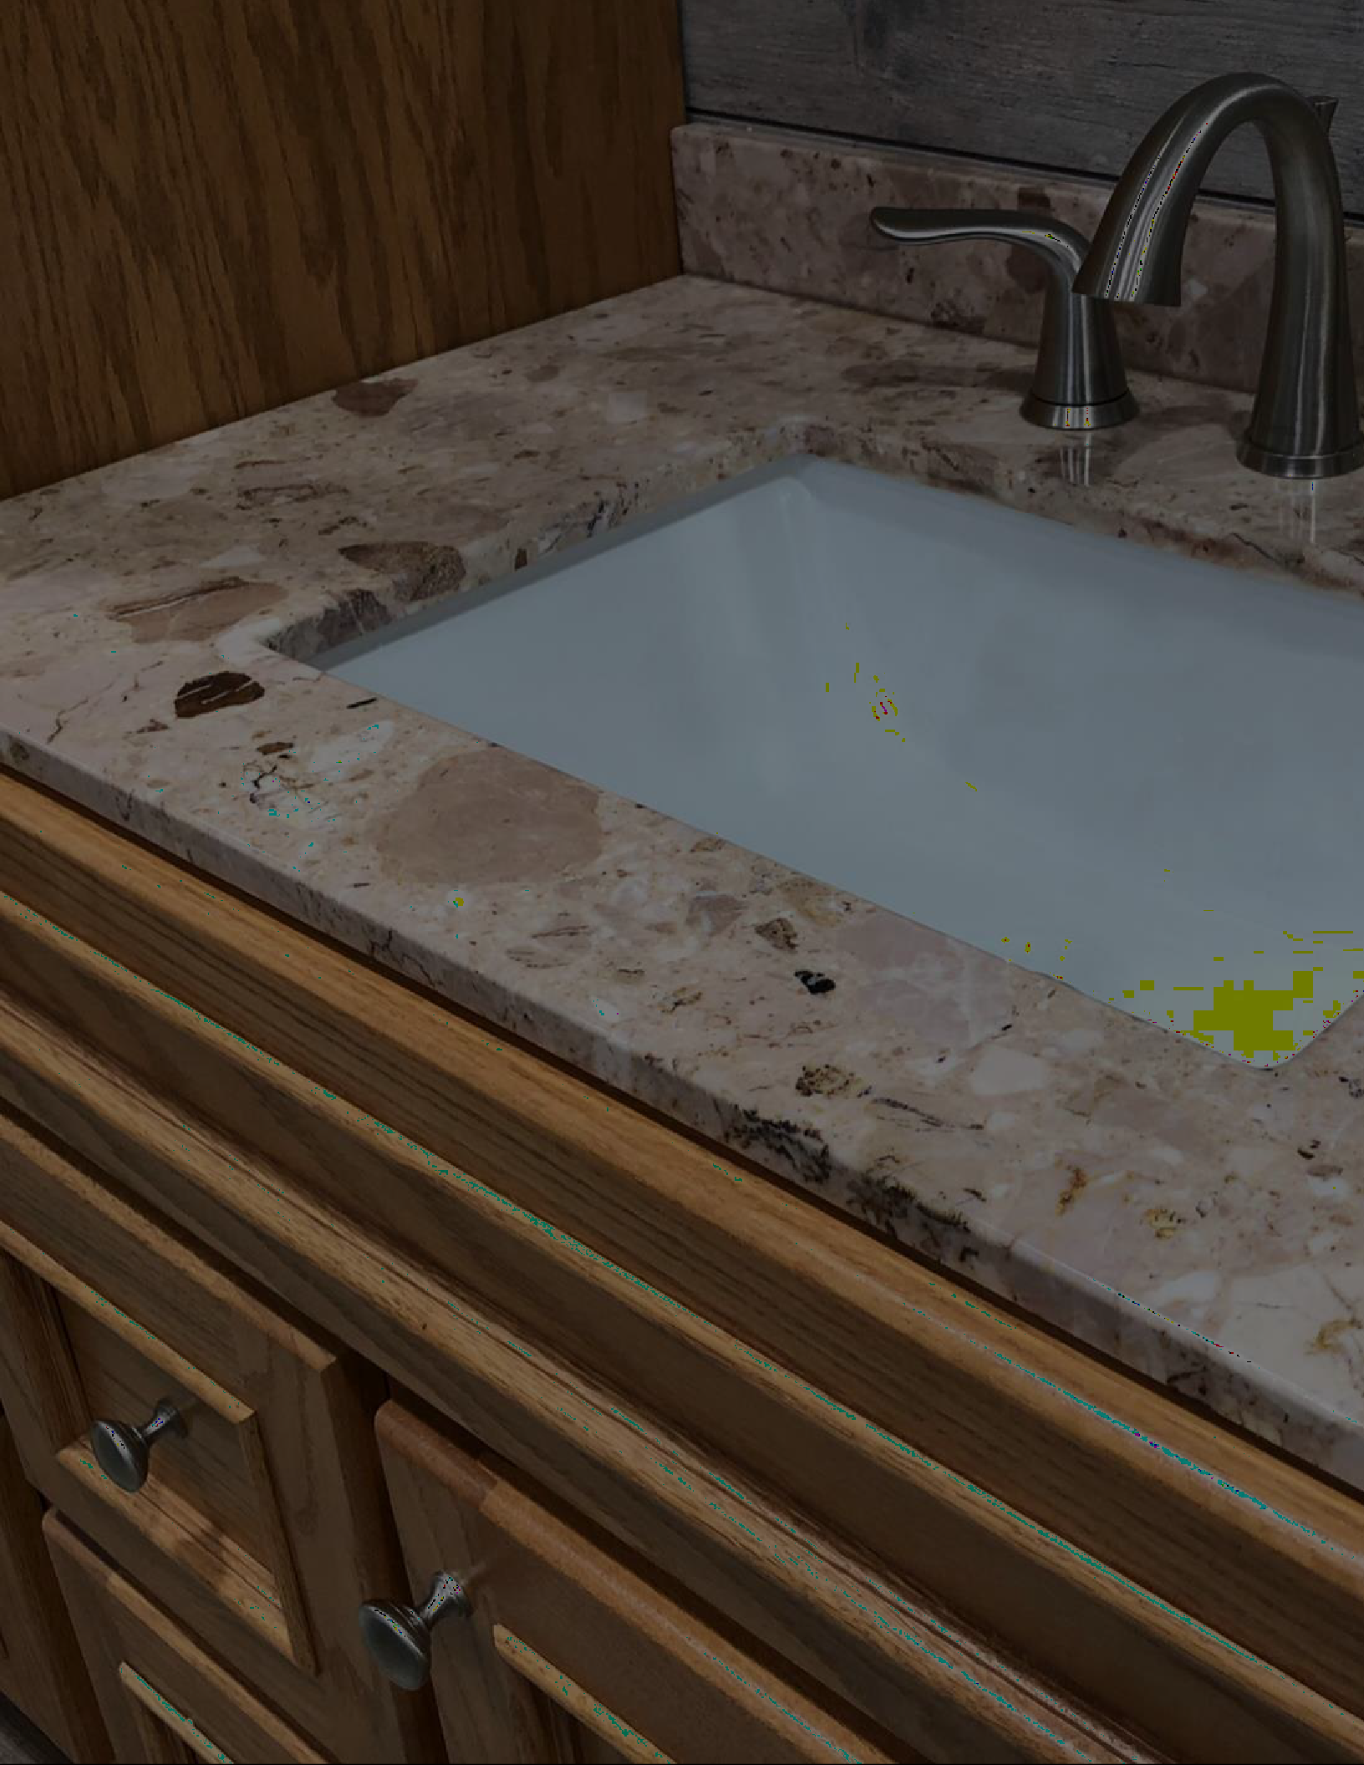








Spending just a little bit of money on a few important things
can make a

impact

7


F A S T S A L
E






7
F A S T
S A L E

Rearrange your furniture to allow for foot traffic through the house. Remove all extra side tables and chairs to make rooms look as large as possible.
Removing rugs and large floor plants can show off gorgeous floors too.

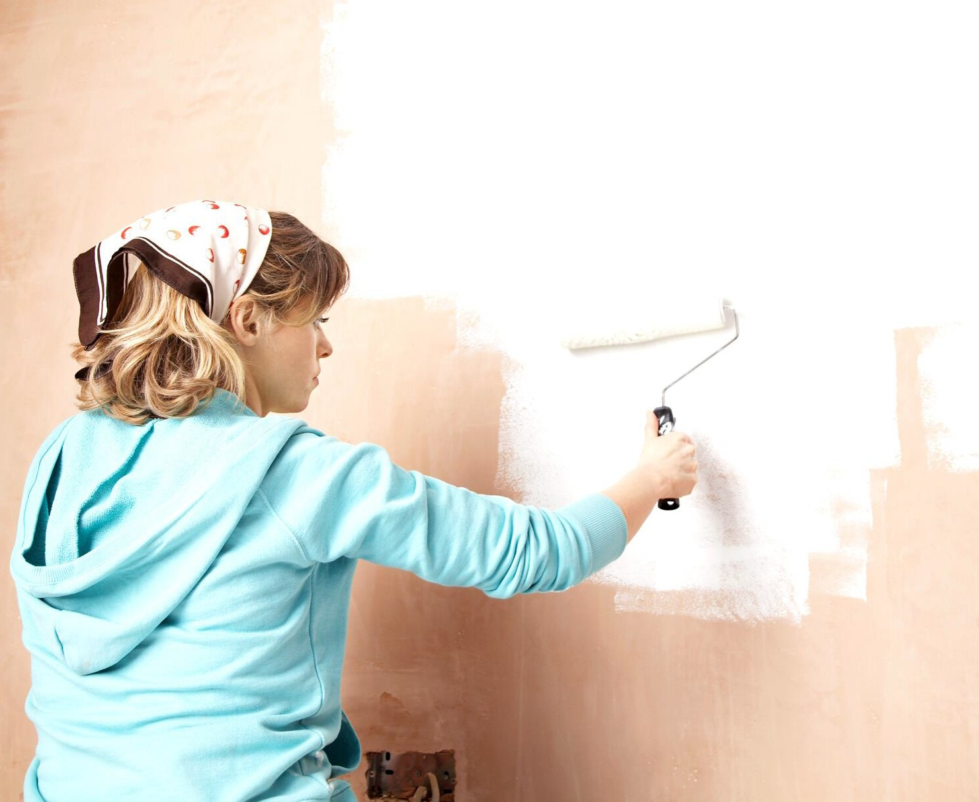



7
F A S T S A L E

Buyers can have a tough time visualizing how different a house would look with a different color on the walls. Spending a little money on a modern yet neutral paint color will pay you back in spades.
Nothing looks worse than a sloppy paint job so if you
don't feel confident doing it yourself, hire a pro.





7
F A S T S A L E

Poor curb appeal can make buyers not even want to get out of the car to go inside a home. Be sure to keep the lawn green and cut with a welcoming front door.

Stage the back porch with comfy furniture so buyers can envision themselves outside enjoying a glass of lemonade on a hot day.





7
F A S T S A L E

If you are using your dining room as an office, for example, or you have an oddly shaped loft area, buyers can become confused wondering what the space is for
Stage it with furniture and props to show them exactly how the room or area can be used.

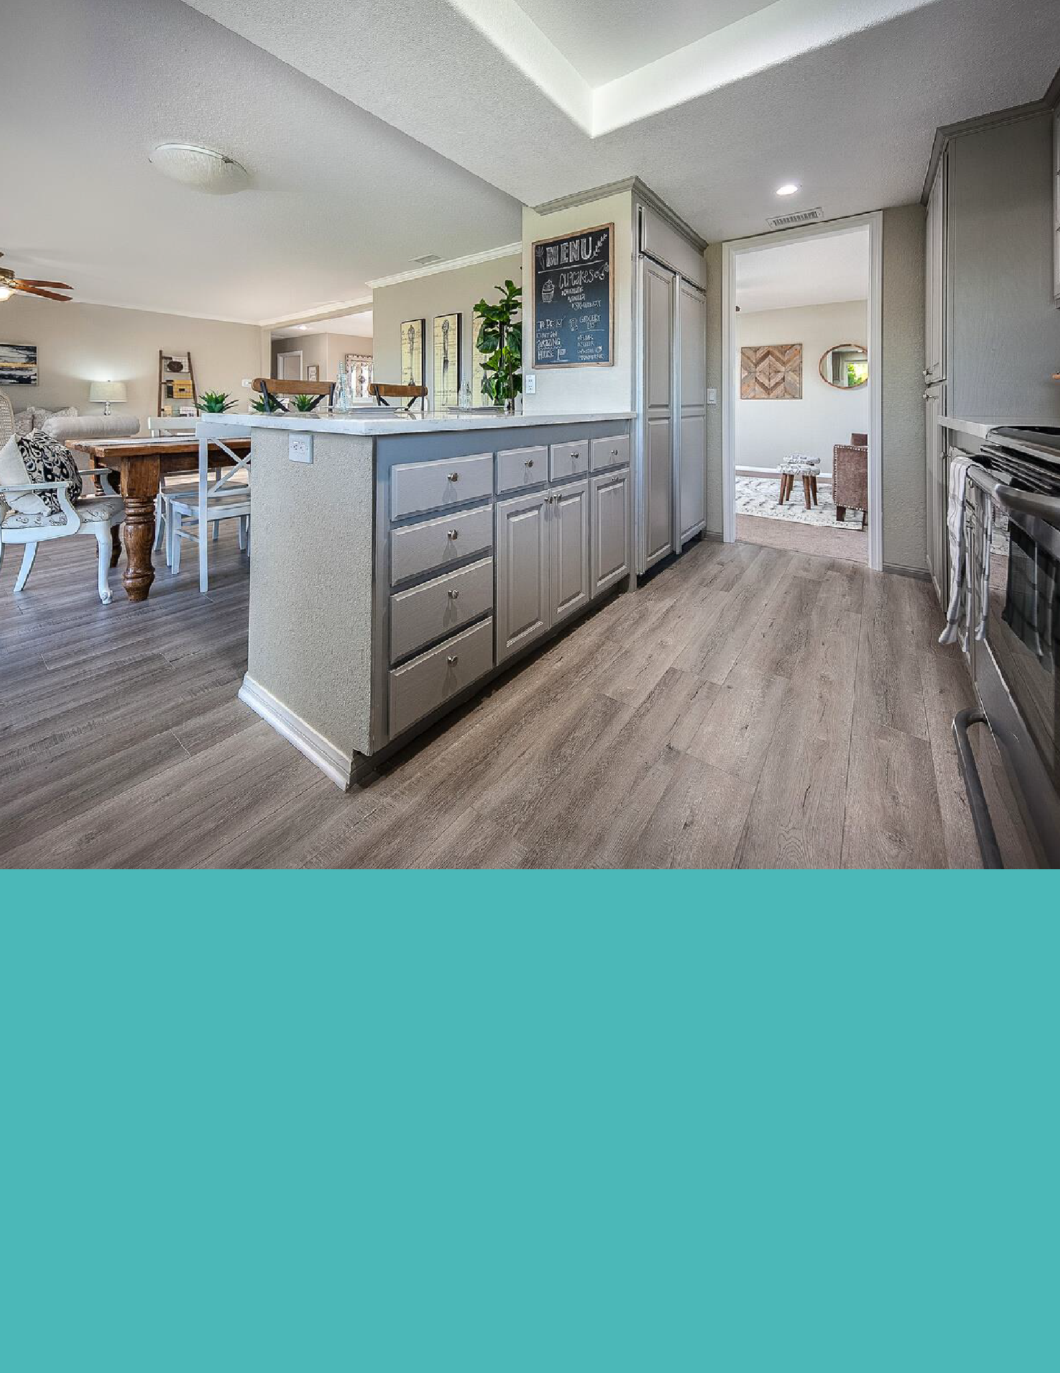



7
F A S T S A L E

If your budget allows for new flooring it's always a worthwhile investment. Nothing is more off- putting than stained and dirty carpeting.
Wood floors, tile, or even luxury vinyl (LVP) are most desirable to buyers.




7
F A S T S A L E

If your bathrooms are dated and grimy, it's possible to completely overhaul the look of a bathroom on just
$700 or so.
Fresh paint, new mirrors, faucets, and lights, towel bars, drawer pulls, and painting the grout white can make a tired bathroom looks modern and sparkling clean.





7
F A S T S A L E

Do not put your house on the market until all the little things you've been meaning to fix have actually been fixed! Minor repairs = big profits. Find a qualified and trusty handyman who can tackle your honey-do list easily. You may not know how to do all this yourself and luckily you don't have to!
As an active Realtor® in town, I can recommend several great people in our area. Feel free to call or email me and I'll share my list of trusted contractors with you.





7
F A S T S A L E

RXB Realty info@rxbrealty.com (855)888-7325
www.rxbrealty.com

