





MISTAKES
First Time
Home Buyers Make

RXB Realty (855)888-7325


It’s so exciting to buy your first home and the temptation to run out and start looking at houses is real. But before you do that, check out this list of mistakes most first time homebuyers make.


Looking at homes without being preapproved
1

Believe me, there is nothing worse than finding a home you absolutely fall in love with and later learning that it is $50,000 out of your price range. By finding out what you can borrow from the bank upfront you will save yourself a lot of heartache.
2

Not having enough money in the bank.

Buying a house is not an inexpensive endeavor. If you use all of the money in your bank account for the down payment and closing costs and have nothing left over, the bank may deny your loan approval at the 11th hour. They cannot take the chance that you will buy the house and then have not enough money to be able to pay the mortgage. Save up what you think you will need for the house and then save up even more before you start shopping. To purchase a $200,000 house you’re going to need a minimum of $10,000 readily available.

RXB Realty www.RXBRealty.com (855)888-7325



Calling the number on for
3
sale signs.

The agent whose sign is in the front yard represents the seller. Therefore their primary goal is to sell that house and get the seller as much money as possible. They cannot also have the primary goal of getting you the best price. If you use that agent to write your offer it is rarely in anyone’s best interest. It costs you no money to hire your own REALTOR® to represent you in the purchase of a house.

Failing to understand the true cost of homeownership.
4

Not only will you pay the mortgage, and pay all of your utilities, pay for homeowners insurance and property taxes, but you will also have to fix things when they break. If you have always been a renter your landlord takes care of this. Now that responsibility falls on you. It’s always a good idea to ask for a one year home warranty paid for by the seller when you buy a house. This way if something breaks during your first year in the home it will often be covered by the warranty. But keep money set aside specifically for home repairs so you are not strapped for cash when anything needs to be fixed.

RXB Realty
(855)888-7325
www.RXBRealty.com


Expecting to find a home that has 100% of the features you want.
We tell people that if they find a home with 75% of the items on their wish list they are doing well. For example, you may want a new home in a gated community with a backyard pool for under $350,000. But is that easy to come by? What if it has all of those things except for the pool? You can always add a pool later or use the neighborhood pool if there is one. Have a conversation with your REALTOR® before you begin house-hunting to set realistic expectations for what you can get in your price range. The most important things are the things you can’t change, such as the location or the neighborhood or the school district. If you hate the blue exterior you can always paint it any color you like down the road.

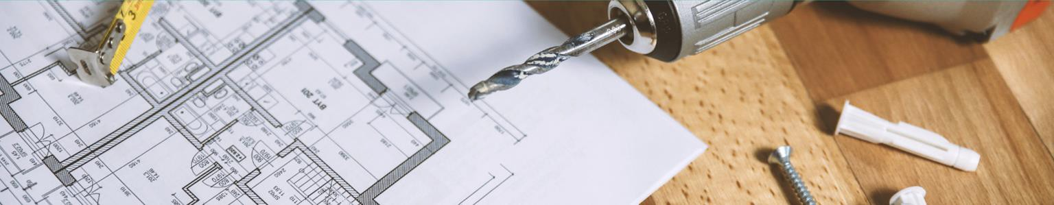
Haggling in a sellers market.
If the market is hot and houses are selling quickly with lots of competition from multiple buyers? This is not the time to come in with a lowball offer. In a sellers market sellers are in the driver seat, meaning they have the leverage in this negotiation. Instead of coming in with a low price try offering terms that would be appealing to them. For example, if the seller doesn’t want to move until the end of May so the kids don’t have to change schools six weeks before the end of the school year could you allow them to remain in the home until then before moving out? Would they prefer to close at the end of the month rather than the beginning of the month to avoid having to pay an additional mortgage payment? Find out what things are important to the seller via your REALTOR® and try to craft an offer that is compelling to them.

RXB Realty www.RXBRealty.com (855)888-7325








7
Not trusting your hired agent to do their job.
Your REALTOR® has most likely helped first time buyers many many many times.
They know what they’re doing. This is why you have hired them – to guide you in
this transaction. If you constantly second-guess their advice, call the seller or the seller’s agent directly to ask questions, you are not helping yourself get the best deal or the best terms. When sellers know how eager you are to get their home they are less likely to negotiate on price or terms. Assuming that you have hired a REALTOR® with experience that you trust, let them do the best they can to assist you. We love helping first time buyers achieve the American dream!

RXB Realty
LICENSE # 123456789
(855)888-7325
Info@RXBRealty.com RXBRealty.COM
- States

