

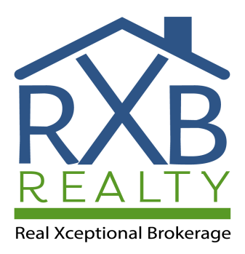

Is Selling FSBO
(For Sale by Owner)
Right for You?

www.RXBRealty.com (855)888-7325
RXB Realty




RXB Realty
www.RXBRealty.com (855)888-7325

If you’re
thinking of selling your home, it can be very appealing to sell it as “For
Sale by Owner” (FSBO). After all, you’ll save a lot of money if you don’t hire a real estate
agent, right? But, if you’re not sure if FSBO is right
for you, keep reading.

Is Selling FSBO Right for You?
Here are some steps you should take – and some questions you should ask yourself – to help you figure out if doing a For Sale by Owner (FSBO) is right for you.

Do you know how to prepare your home for sale? Do you feel confident that you know what buyers are looking for in today’s market? Do you know which things need to get fixed up front and which things you can skip? Do you know how to make your home as visually appealing as possible once it goes on the market?
01
If your answer is yes, move onto the next step.

Do you feel confident coming up with an asking price for your house? Overpricing your house is usually the kiss of death. There’s nothing worse than cleaning like a crazy person for weeks and listing the house for sale – only to be met with crickets. Listing your house at too high of a price will result in a lack of showings.
02
And even if you come up with a price, ask yourself: Will your house

appraise for that price? Do you have comps to back up the price? Don’t just look at that Zillow estimate – remember, this is just a computer- generated ballpark estimate and can’t be taken as fact.
03
Do you know which disclosures are legally required in your area? Do you know how to fill out those forms?
One of the most common lawsuits in the real estate industry is from buyers who bought a house and allege that the sellers failed to tell them material facts about the property prior to their purchase. Nothing
will ruin your day faster than getting sued!

Do you know how to market the home? Do you know how to make it look amazing online with photos and virtual tours? Do you know where to advertise it? Do you know how to get it in front of as many eyeballs as possible? Do you feel like you can do a good job promoting it in all avenues?
04
If your answer is yes, move onto the next step.

Are you a good negotiator? There are a few typical types of buyers who approach FSBO properties. Usually, this includes investors looking to pay pennies on the dollar because they will buy the house in its ‘as-in condition’ and pay cash very quickly.
05
Other buyers include those who are not creditworthy and will ask you to do a lease with an option to purchase down the road. If you need the money from the sale of this house, you will not be able to accommodate them, so now you’ve wasted your time to show them the property. Other buyers will write low offers
because they know you are not paying a REALTOR® a commission to sell it. Since you are saving the money on the commission, they feel justified about offering you less as well.
06
Are you comfortable letting strangers into your house repeatedly? You don’t want to hover during showings because if the buyers can’t speak freely about what they think about the home, they will not be able to imagine themselves living there. But if you are not present, you could easily be robbed. It takes skill to be present while still allowing your
potential buyers enough privacy to discuss amongst themselves.

Do you know what to do in case of a low appraisal? For instance, if the home inspector flags items for repair or if title issues arise during the sales period? Will you be able to save the sale?
07

If you’re confident in all of the above mentioned areas, doing a
For Sale by Owner (FSBO) may be a good choice for you.



RXB Realty
www.RXBRealty.com (855)888-7325

However, keep this in mind: Most FSBO sellers still end up paying a percentage of the home's sale price in commission, usually a minimum of 3%. Agents representing buyers will often want to show your property to their client BUT only if you pay their fee. If you’ll still be paying a commission to the agent who brings a ready, willing,
and able buyer, it’s not much more to hire an agent to represent YOU in the
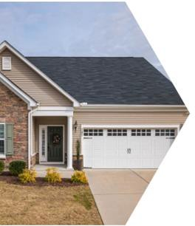
transaction as well. The amount of money that you save in the commission is often minimal after paying a photographer, advertising costs, other marketing costs not to mention all of your time spent coordinating the sale. Also, note that FSBO homes typically sell for less than
homes listed with a real estate agency, so what you save in commission you
may lose on the actual sales price.
Lastly, by not listing your home on the MLS, you severely limit the number of people who will even know your home is for sale. By reaching fewer buyers, you will get fewer offers. Agents don't have easy access to FSBO properties and the only ones who'll call you about it are usually trying to list your home, not sell it.

If you want to sell your home faster and for more money – enough to pay a real estate agents’ commission for listing your home – it might make sense to save yourself all the work and hire a professional who does this every day to assist you.

