
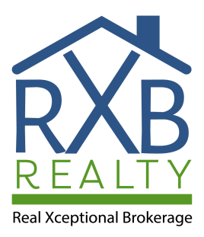

USING YOUR VA ENTITLEMENT
T O B U Y A H O M E




WE SERVE THOSE WHO SERVE

This guide is meant to provide some helpful tips about VA home loans. For more detailed information please be sure to work with a REALTOR® and a lender who are familiar with VA loans.

www.RXBRealty.com (855)888-7325




WHO IS ELIGIBLE?

www.RXBRealty.com (855)888-7325

YOU SERVED
90 consecutive days of active service during wartime

YOU SERVED
181 consecutive days of active
service during peacetime

YOU SERVED
More than 6 years of service in the National Guard

YOU SERVED
More than 6 years of service in
the Reserves

YOU MAY BE ELIGIBLE FOR
A VA LOAN IF...


You should speak to Dave Elkins VA Loan Expert about your options and other qualifications to verify that you are indeed eligible for a VA loan. Dave Elkins (440)477-5652

VA LOAN
BENEFITS

NO DOWN PAYMENT REQUIRED
Less money due at the time of
purchase

NO MORTGAGE INSURANCE REQUIRED
Lower monthly payments since there
is no mortgage insurance (MI)

LOW INTEREST RATE AND LENIENT CREDIT REQUIREMENTS
Lower upfront AND monthly costs



www.RXBRealty.com (855)888-7325



ARE YOU READY?

www.RXBRealty.com (855)888-7325



GET FINANCIALLY PREPARED
Make sure you have some money in the bank for closing costs, home inspections, and the appraisal. It's ideal to have at least 3% of the purchase price readily available to put toward purchasing a home.
A solid credit score shows your ability to repay debt. If your credit score is high your interest rate will be lower.
www.RXBRealty.com (855)888-7325



0%

The #1 reason many vets opt to buy a home with a VA
loan is that there is NO DOWN PAYMENT required.
The interest rates are often lower as well.
www.RXBRealty.com (855)888-7325

$0?

Can you buy a house with no money down at all?
Not exactly. You still need to pay closing costs, which are usually between 3-4% of the sales price. Often the seller will pay for some (or even all) of your closing costs.
You'll also need earnest money and money for any home inspections.




www.RXBRealty.com (855)888-7325

Funds Needed

UP TO 4%
Closing costs are fees involved with processing the loan. The seller can contribute to this.

$350
Average cost for a whole home inspection - not required but HIGHLY recommended

$450 $350

Cost for the appraisal - ask your lender if you pay up front of if they include it in their closing costs
Misc other inspections that may be required, such as septic, roof, or a property survey (may or may not be required)



www.RXBRealty.com (855)888-7325

Begin the preapproval process and
start looking for homes.

MONTH 2

Your lender typically needs 30
-40 days to process your loan.

MONTH 4
MONTH 1

Find the ideal home, write an offer,
and go under contract.

MONTH 3

Plan to close 4-6 weeks from going under contract. Congratulations!!!



TIMELINE OF BUYING A HOME
HOW LONG DOES IT TAKE?
www.RXBRealty.com (855)888-7325


DO ALL HOMES QUALIFY?

No Fixer Uppers
The VA requires that the homes their veterans buy be safe, clean,
and secure. The VA also requires the house be free of termites.

Owner Occupied
The VA only loans money to buyers who plan to live in the house, not for investment properties.
Condos / Townhomes
Only complexes approved by the VA are eligible

www.RXBRealty.com (855)888-7325

Pick a loan officer that is well versed in VA loans and local to the area you are purchasing in. Online lenders attract buyers with low fees but they can often be slow to respond and hard to get a hold of. Your REALTOR® can give you several names of good lenders.
CHOOSING A LENDER




www.RXBRealty.com (855)888-7325




RXB Realty IS A MILITARY SPECIALIST
Veterans have special needs and requirements. You deserve an agent who understands those needs.
www.RXBRealty.com (855)888-7325



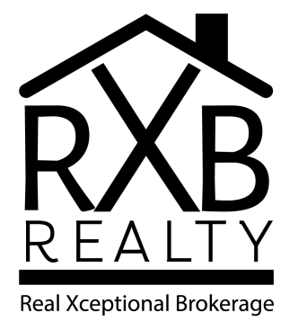
RXB
Realty

Phone Number
(855)888-7325

Email Address
info@RXB Realty.com

Website
www.RXBRealty.com



READY TO GET STARTED?
We would love to assist you!

www.RXBRealty.com (855)888-7325

